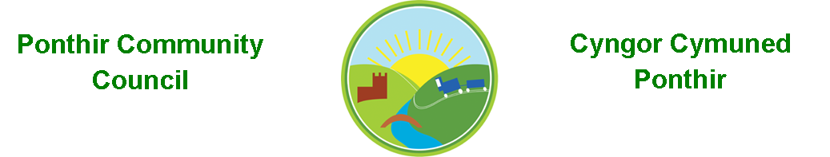
17 June 2020

Dear Councillor,

You are summoned to attend the Monthly Meeting on Monday 22nd June 2020 as an online meeting as sent by ,
Mrs. Karen Kerslake
Clerk

This meeting will be held in accordance with

Local Authorities (Coronavirus) (Meetings) (Wales) Regulations 2020

Agenda
- Present
- Apologies
- Declarations of Interest
- To consider matters raised by the members of the public present (N.B. Such matters will be reported upon by the Clerk at the next meeting, where appropriate)
- To receive a police report.

- To approve the minutes of the Monthly Meeting held on 9th March 2020.
- Matters arising from the Monthly Meeting held on 10th February 2020.
  - Drains/Flooding/Potholes – Information still not received from TCBC. Cllr Bevan has taken up the issue of potholes – awaiting report
  - Proposed Changes to Caerleon School Catchment Area – Responses from Cllr Huw Bevan and David Davies MP attached. Executive Member for Education, Cllr Richard Clark emailed, no response received as yet
- Internal Audit Report (attached)
- Annual Meeting/Election of Chair/Council Vacancy (See Torfaen County Borough Council notice attached)
- Finance and Accounts
- Balance of Direct Plus Account as at 31st May 2020 = £30,842.69
- To approve the following cheques
  - Garden Services £540.00
  - Torfaen Payroll Services £60.46
  - Insurance £434.94

- To Note Standing Order/Direct Debit Payments
- Traffic through the village during lockdown – Cllr L Ryan-Scales

- Planters in Llanfrechfa – Cllr S Bailey

- Planning Applications
  - Change of use from ancillary accommodation (annexe)topermanent residential dwelling and new garage for Lysbrechfa House
LOCATION: Llysbrechfa House, Church Road, Llanfrechfa
  - Proposed single storey side extension
LOCATION: 1 Laburnum Cottages, Caerleon Road, Ponthir

- The next meeting of the Council will be the Annual Meeting, date to be confirmed.

This document is available on our website www.ponthircommunitycouncil.gov.uk
A copy of this document could be made available in Welsh. Please contact us on the telephone number or e-mail below. / Mae dogfen yma yn ar gael mewn gwefan ni www.ponthircommunitycouncil.gov.uk Mae copi or ddogfen hon ar gael yn Gymraeg.
Cysylltwch a ni ar y rhif ffôn neu drwy e-bost isod.
Telephone/ Ffôn: 07971948351 E-Mail/ E-bost: clerk@ponthircommunitycouncil.gov.uk

