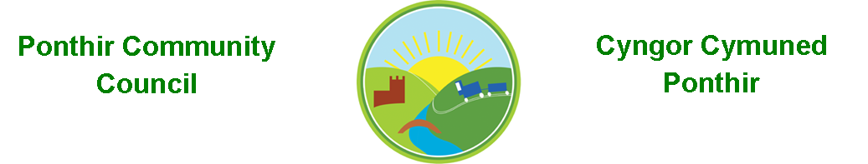
9th August 2020

Dear Councillor,
You are summoned to attend the Monthly Meeting to be held in accordance with the Coronavirus Regulations (Wales) 2020. Meeting is to be held virtually on 14th September 2020 @ 7pm.

Press and public welcome.
Mrs. Karen Kerslake

Agenda
- Present
- Apologies
- Declarations of Interest
- To consider matters raised by the members of the public present (N.B. Such matters will be reported upon by the Clerk at the next meeting, where appropriate)
  - Trees to the rear of 3 Candwr Park – Cllr Bailey
  - Removal of Play Equipment by Torfaen CBC at Barnfield – various members of the public reporting.
  - Speeding in the village – Resident.
- To receive a police report.
- To approve the minutes of the Monthly/Annual Meeting held on 10th August 2020
- Matters arising from the Monthly Meeting held on 10th August 2020
- TCBC Tree Policy - observations.
- Community Garden/Planters – Update from Clerk
- Finance and Accounts

- Balance of Direct Plus Account as at 28th August 2020 £35,113.47
- To Approve the Following Cheques
  - K Kerslake for investigation into laptop recovery £15 (paid in cash)
  - Ponthir District Sports Club Ltd £45 for venue bookings 2020

- To Note Standing Order/Direct Debit Payments
    - TCBC (Clerk’s Salary) August 2020 £456.73
    - Information Commissioners Office £35

- Update on Banking Changes - Clerk

- Planning Permission
  - DEVELOPMENT PROPOSED: Erection of rear extension and side porch with updated boundary details for existing dropped kerb and new driveway. LOCATION: Banff Springs, 105 Hafod Road, Ponthir
  - Demolition of existing garage and development of new garage block with granny annexe above LOCATION: Catoni, Candwr Road, Ponthir

- Remembrance Sunday. - Wreaths

- Any other Business

- To Note Correspondence Received

  - Notice of meetings ABCHC – Aneurin Beven Health Board
  - Community Venue Guidance TVA
  - Cabinet Decisions TCBC
  - Training dates One Voice Wales
  - Gwent Valleys Committee One Voice Wales
  - Park in Barnfield Cllr Huw Bevan
  - Grange University Hospital Aneurin Bevan Health Board
  - Audit Committee TCBC
  - Planning Committee TCBC
  - Planning Applications x 2 TCBC
  - Scam Warning OVW (to be uploaded to website)
  - Speeding in Village Resident
  - Newsletter TCBC
  - Tree Felling at rear of Oaklands John Palmer
  - Community Farm Reopening TCBC
  - Advice and guidance – meetings OVW
  - Barnfield Play Area TCBC – Kelvin Edwards
  - Barnfield Play Area Resident
  - Drain Survey Linda Ash, TCBC

- To confirm IT platform for the next Monthly Meeting of the Council on 12th October 2020 and subsequent meetings.

This document is available on our website www.ponthircommunitycouncil.gov.uk
A copy of this document could be made available in Welsh. Please contact us on the telephone number or e-mail below.
Mae dogfen yma yn ar gael mewn gwefan ni www.ponthircommunitycouncil.gov.uk Mae copi or ddogfen hon ar gael yn Gymraeg.
Cysylltwch a ni ar y rhif ffôn neu drwy e-bost isod.
Telephone/ Ffôn: 07789 640709 E-Mail/ E-bost: clerk@ponthircommunitycouncil.gov.uk

