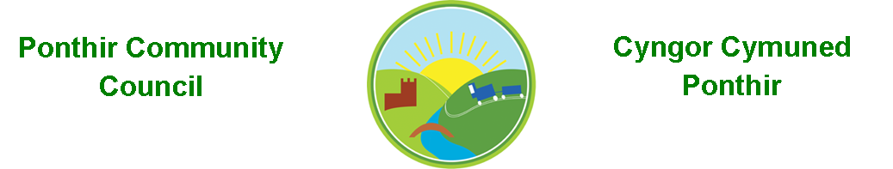
9th August 2020

Dear Councillor,
You are summoned to attend the Monthly Meeting to be held in accordance with the Coronavirus Regulations (Wales) 2020. Meeting is to be held virtually on 12th October 2020 @ 7pm.

Press and public welcome.
Mrs. Karen Kerslake

Agenda
- Present
- Apologies
- Declarations of Interest
- New councilor declaration
- To consider matters raised by the members of the public present (N.B. Such matters will be reported upon by the Clerk at the next meeting, where appropriate)
  - Afon Llwyd works – Natural Resources Wales
  - Play Area – Barnfield
  - Planting of twisted willows on Caerleon Road
  - Speed cameras – resident wishing to assist in monitoring
- To receive a police report.
- To approve the minutes of the Monthly/Annual Meeting held on 14th September 2020
- Matters arising from the Monthly Meeting held on 14th September 2020

- Finance and Accounts

- Balance of Direct Plus Account as at 30th September 2020 £34,411.48
- Cheques/Online payments made
  - Ponthir District Sports Club £45
  - Zoom – online meeting platform £115.10
  - Royal British Legion £34.00

- To Note Standing Order/Direct Debit Payments
    - TCBC (Clerk’s Salary) September £456.73
    - Swalec - £130.80 (Backdated for rest of 2020)

- Budgets - Clerk

- Planning Permission

  - Erection of rear extension and side porch with updated boundary details for existing dropped kerb and new driveway. LOCATION: Banff Springs, 105 Hafod Road, Ponthir
  - Two-storey side extension LOCATION: Acorn House, Caerleon Road, Ponthir
  - Demolition of existing single storey side extension, erection of 2-storey side and rear extension with balcony LOCATION: 19 Moyle Grove, Ponthir, Cwmbran

- Any other Business

- To Note Correspondence Received
  - Armed forces in Wales Awards TCBC
  - Free webinar community venues TVA
  - Phishing Scams OVW
  - Park in Barnfield Huw Bevan
  - Notice Cabinet TCBC
  - Notice Planning Committee TCBC
  - Weekly Bulletin x 4 TCBC
  - Trees in Ponthir TCBC
  - Gwent Valleys Area Committee Meeting OVW
  - Notice Council TCBC
  - Decision sheets – Cabinet TCBC
  - Coronavirus updates OVW
  - Supplemental Planning Decisions TCBC
  - Room booking invoice PDSC
  - Notice Cleaner Communities Scrutiny TCBC
  - Notice Prosperous Communities Scrutiny TCBC
  - Access codes HCI Data

        - TCBC – Torfaen County Borough Council
        - OVW – One Voice Wales
This document is available on our website www.ponthircommunitycouncil.gov.uk
A copy of this document could be made available in Welsh. Please contact us on the telephone number or e-mail below.
Mae dogfen yma yn ar gael mewn gwefan ni www.ponthircommunitycouncil.gov.uk Mae copi or ddogfen hon ar gael yn Gymraeg.
Cysylltwch a ni ar y rhif ffôn neu drwy e-bost isod.
Telephone/ Ffôn: 07789 640709 E-Mail/ E-bost: clerk@ponthircommunitycouncil.gov.uk

