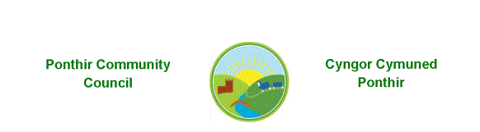
PONTHIR COMMUNITY COUNCIL
GRANT APPLICATION FORM 2020/21
Please complete this form as fully as possible, attach it to the latest available accounts and a copy of the organisations rules/constitution, as required by the Grants Criteria.
Please send the form and supporting documentation to
Karen Kerslake, Clerk, Ponthir Community Council, 79 Candwr Park, Ponthir, NP18 1HN
If you would prefer to send it electronically, please email clerk@ponthircommunitycouncil.gov.uk or telephone me with any questions on 07789 640709
