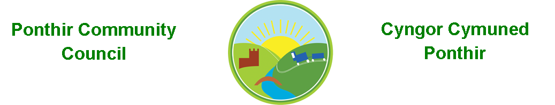
6th January 2021

Dear Councillor,
You are summoned to attend the Monthly Meeting to be held in accordance with the Coronavirus Regulations (Wales) 2020. Meeting is to be held virtually on 11th January 2021 @ 7pm.

Press and public welcome.
Mrs. Karen Kerslake

Agenda

- Present
- Apologies
- Declarations of Interest
- Police Report – To be deferred to February 2021 meeting (Figures not available).
- To consider matters raised by the members of the public present (N.B. Such matters will be reported upon by the Clerk at the next meeting, where appropriate)
  - Pavement outside of Twyn Cottages
  - Letter of support
  - Future development of PDSC
  - Flooding in Ponthir/Potholes – December 2020
  - Overgrown brambles and nettles
- To approve the minutes of the Monthly Meeting held on 14th December 2020
- Matters arising from the Monthly Meeting held on 14th December 2020
  - Barnfield Play Area – Update from Clerk
  - Community Gardens update – Clerk
  - Phone Box in Llanfrechfa – Clerk
  - Proposed LDP – Clerk

- Council Precept – 2021-22
a. TCBC letter attached

- Finance and Accounts

- Balance of Direct Plus Account as at 31st December 2020 £38,019.83
(Detailed breakdown of accounts to be deferred until Feb 2021 meeting – waiting for bank statement)
- Cheques/Online payments made
  - Microsoft – new laptop license £59.99
- To Note Standing Order/Direct Debit Payments
    - TCBC (Clerk’s Salary) October £456.73
    - Swalec - £16.08
- Notice of Audit Completion
  - Attached
  - Future Audit arrangements

- Grant Applications Received
  - PDSC (Attached)
  - Llantarnam Grange Arts Centre (Attached)
  - Wales Air Ambulance Emergency Appeal (Attached)

- Planning Permission
  - DEVELOPMENT PROPOSED: Three flues for biomass boilers. Retrospective permission for one flue which is already installed in building 1 and permission for two flues in building 2.
LOCATION: Brechfa Farm, Caerleon Road, Llanfrechfa

- Any other Business
  - Economy and Skills Strategy Consultation

- To Note Correspondence Received

  - Police Training OVW
  - Newletters x 3 TCBC
  - Council Planning Decisions TCBC
  - Notice of Meetings ABuHB
  - Planned Ministerial events OVW
  - Caerleon College Redevelopment P. Brown
  - Support and assistance (weekly) HMRC
  - Mobile Testing Facilities ABuHB/TCBC
  - Grant application J Parfitt
  - Offer of Services TVA
  - Brexit Information Commissioner
  - Consultation on Crownbridge School TCBC
  - Newsletter Congress Theatre
  - Quotation T Morgan
  - College Redevelopment H Bevan
  - Amendment to Traffic Orders TCBC
  - Overgrown brambles and nettles Resident
  - Play Equipment TCBC
  - Private footpath Resident
  - Request for Consultation Skills Strat TCBC

        - TCBC – Torfaen County Borough Council
        - OVW – One Voice Wales
        - WLGA – Welsh Local Government Assoc.
        - ABuHB – Aneurin Bevan University Hospital Board
This document is available on our website www.ponthircommunitycouncil.gov.uk
A copy of this document could be made available in Welsh. Please contact us on the telephone number or e-mail below.
Mae dogfen yma yn ar gael mewn gwefan ni www.ponthircommunitycouncil.gov.uk Mae copi or ddogfen hon ar gael yn Gymraeg.
Cysylltwch a ni ar y rhif ffôn neu drwy e-bost isod.
Telephone/ Ffôn: 07789 640709 E-Mail/ E-bost: clerk@ponthircommunitycouncil.gov.uk

