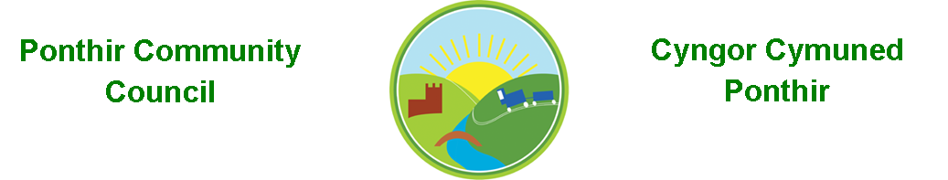
9th June 2021

Dear Councillor,
You are summoned to attend the Annual General Meeting to be held in accordance with the Coronavirus Regulations (Wales) 2020. Meeting is to be held virtually on 14th June 2021 at 6.30pm at the PSCC.

Press and public welcome.
Mrs. Karen Kerslake

Agenda

- Present
- Apologies
- Election of Chair
- Election of Vice-Chair

- Declarations of Interest

- Chairman’s Annual Report (if available)

- Date of monthly meetings up to May 2022

- Review of expenditure under s137

- Election of Representatives to,
  - Ponthir Church in Wales school
  - Torfaen County Association of Local Councils (TCALC)
  - Gwent Valleys Partnership
  - PDSC
  - Any other committees/organisations

This document is available on our website www.ponthircommunitycouncil.gov.uk
A copy of this document could be made available in Welsh. Please contact us on the telephone number or e-mail below.
Mae dogfen yma yn ar gael mewn gwefan ni www.ponthircommunitycouncil.gov.uk Mae copi or ddogfen hon ar gael yn Gymraeg.
Cysylltwch a ni ar y rhif ffôn neu drwy e-bost isod.
Telephone/ Ffôn: 07789 640709 E-Mail/ E-bost: clerk@ponthircommunitycouncil.gov.uk

