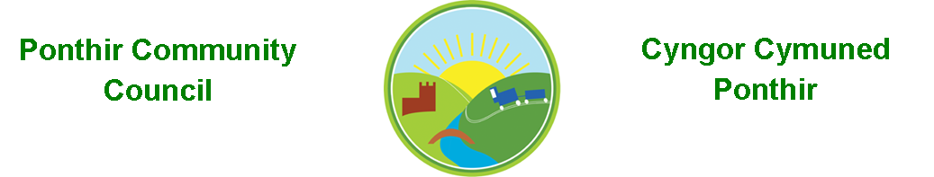
7th April 2021

Dear Councillor,
You are summoned to attend the Monthly Meeting to be held in accordance with the Coronavirus Regulations (Wales) 2020. Meeting is to be held virtually on 12th April 2021 @ 7pm.

Press and public welcome.
Mrs. Karen Kerslake

Agenda

- Present
- Apologies
- Declarations of Interest
- To consider matters raised by the members of the public present (N.B. Such matters will be reported upon by the Clerk at the next meeting, where appropriate)

- To approve the minutes of the Monthly Meeting held on 8th March 2021

- Crime/ASB Report
- Matters arising from the Monthly Meeting held on 8th March 2021
  - Flooding/Drains/Potholes – update from Clerk
  - Local Development Plan – update from Clerk
  - Christmas Lights Quotation Received – Cllr Davies/Clerk
  - Community Garden – Update – Cllrs Danaher/Bailey
  - Planting Scheme – To include entrance to Candwr Park as resident who has looked after it to date is moving. – completed
  - Magazine articles – Cllr Davies
  - Dog fouling update – Clerk
  - Change of wording to Procurement Standing Order – Cllr Bailey

- Finance and Accounts

- Balance of Direct Plus Account as at 31st March 2021 £34,417.87
- Bank Reconciliation Q4 - attached

- Cheques/Online payments made
None
- To Note Standing Order/Direct Debit Payments
    - Swalec - £16.08
    - Clerk’s salary - £456.73

- Planning Permission

DEVELOPMENT PROPOSED: Proposed single storey side extension
LOCATION: 8 Badgers Meadow, Ponthir, Cwmbran

- Any other Business

- To Note Correspondence Received
  - Latest Update Information Commissioner
  - Agenda for Council TCBC
  - Help and Support x 4 HMRC
  - Update on Covid Regs OVW
  - Training available OVW
  - Meeting Notification OVW
  - Notice of Disconnection SWALEC
  - Boating Lake x 2 TCBC
  - Tree Felling on A4049 TCBC
  - Planning Application TCBC
  - Newsletters x 4 TCBC
  - Agenda for Planning TCBC
  - Green Waste TCBC
  - Covid Updates x 4 TCBC
  - Road Repairs TCBC
  - Census x 2 TCBC/ONS
  - Invoice OVW
  - Additional Dog Bins Cllr H Bevan
  - Easter Holidays Congress Theatre
  - Audit Committee TCBC
  - Supplemental Decisions TCBC Planning
  - Agenda Cabinet TCBC
  - Notice of Audit Wales Audit Office
  - Blocked Drains TCBC
  - Road Repairs Stokes Ct TCBC
  - Guidance for Pre Election TCBC
  - Countryside Code OVW
  - Newsletter ABuHB
  - Guidance on Covid WLGA

        - TCBC – Torfaen County Borough Council
        - OVW – One Voice Wales
        - WLGA – Welsh Local Government Assoc.
        - ABuHB – Aneurin Bevan University Hospital Board
This document is available on our website www.ponthircommunitycouncil.gov.uk
A copy of this document could be made available in Welsh. Please contact us on the telephone number or e-mail below.
Mae dogfen yma yn ar gael mewn gwefan ni www.ponthircommunitycouncil.gov.uk Mae copi or ddogfen hon ar gael yn Gymraeg.
Cysylltwch a ni ar y rhif ffôn neu drwy e-bost isod.
Telephone/ Ffôn: 07789 640709 E-Mail/ E-bost: clerk@ponthircommunitycouncil.gov.uk

