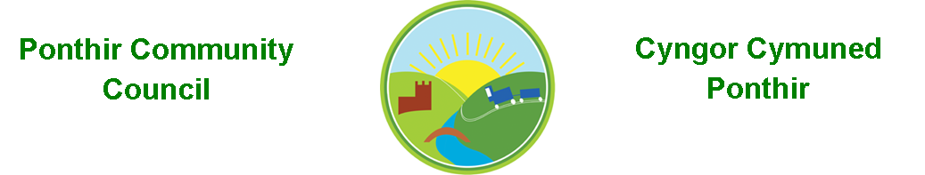
8th September 2021

Dear Councillor,
You are summoned to attend the Monthly Meeting to be held in accordance with the Coronavirus Regulations (Wales) 2020. Meeting is to be held on 13th September 2021 @ 7pm, Ponthir Sports and Community Club

Press and public welcome.
Mrs. Karen Kerslake

Agenda

- Present
- Apologies
- Declarations of Interest
- To consider matters raised by the members of the public present (N.B. Such matters will be reported upon by the Clerk at the next meeting, where appropriate)

- To approve the minutes of the meeting held on 14th July 2021

- Matters arising from the Monthly Meeting held on 14th June 2021
  - Complaint to Torfaen County Borough Council in relation to,
    - Tree maintenance
    - Drainage
    - Communication on proposed Local Development Plan and the suggestion of 1200 houses at Llanfrechfa Grange. Clerk/Cllr Danaher to update.
  - Speeding in Ponthir – Speeding signage has been circulated via email, but the suggestion has also been tabled around speed bumps or chicanes.- Clerk has contacted the Highways Department to determine the process for either chicanes or speed bumps and whether these would be an option under Highways legislation to purchase.
  - Police attendance at a future meeting – Clerk to update
  - SWALEC – Complaint to SWALEC has been made but monthly price of the service has increased to £23.99 per month. Update at meeting by Clerk
  - Community Garden – No update from TCBC at this time.
  - Magazine articles – Agreed the timescales will be Autumn and Spring. Clerk to circulate what has already been done for the next meeting
  - Communications – Clerk to update
  - Christmas Lights – Lights have been ordered and received. SSE are currently installing the connections on lamp posts in Ponthir. Awaiting invoice for the work and confirmation of beginning of December 2021 for installation of lights. Currently in storage.
  - PSCC Proposal – Cllr Danaher/Clerk
  - Christmas Tree and winter fayre – Clerk to update proposals at the meeting.
  - Benches in Ponthir – Clerk to update around including development at PSCC.
  - Wildlife Pond – Suggestions have been made to site the pond at the sports field. Cllr Morgan/Cllr Bailey to update on recent meetings with One Voice Wales and TCBC. Cllr Danaher/Clerk to update on recent changes to plan.
  - Cllr Ryan-Scales to look at cost/organization of annual Bath trip.
  - Letter to resident relating to speeding – completed
  - Plaque to commemorate the visit of HRH to Ponthir House – Clerk to update
  - Cleaning of bus stops and bin.- Cllr Danaher
  - Greening requests to Torfaen Street Scene – all completed apart from info on wildflower planting tops of bus stops.
  - Memorial Stone in Ponthir Church for rememberance. – discussion.
  - Relocation of filing cabinets - Completed

- Finance and Accounts

- Balance of Direct Plus Account as at 31st August 2021 £30,407.56

- Cheques/Online payments made

02.08.21 Acorn £240.00
04.08.21 Storage £750.00
11.08.21 Postage £ 7.65
19.08.21 Grant £100.00
27.08.21 Lighting £3,038.04

- To Note Standing Order/Direct Debit Payments
20.08.21 Payroll £456.73
20.08.21 Swalec £ 23.99
13.08.21 ICO £ 35.00

- 2020/21 Annual accounts submitted to Wales Audit Office in accordance with statutory timescales, rules and regulations. Notice for inspection of accounts is now on website/notice boards.

- Planning Permission
Application for the installation of a 5G mast at the corner of School Close – Council strongly objected to application and the proposal was refused in August by Torfaen. Another application has been submitted for a reduced height mast but in the same location. Ponthir Community Council has tabled objections to any development of this sort in the proposed area and feel the need for futher mobile phone coverage should be balanced with the needs of users of pavements, schools and anyone with mobility issues. There are other locations available and Ponthir Community Council has offered to work with the applicant to find a more suitable location. – locations to be discussed.

- Any other Business

- To Note Correspondence Received
  - Very little of note received during the period

This document is available on our website www.ponthircommunitycouncil.gov.uk
A copy of this document could be made available in Welsh. Please contact us on the telephone number or e-mail below.
Mae dogfen yma yn ar gael mewn gwefan ni www.ponthircommunitycouncil.gov.uk Mae copi or ddogfen hon ar gael yn Gymraeg.
Cysylltwch a ni ar y rhif ffôn neu drwy e-bost isod.
Telephone/ Ffôn: 07789 640709 E-Mail/ E-bost: clerk@ponthircommunitycouncil.gov.uk

