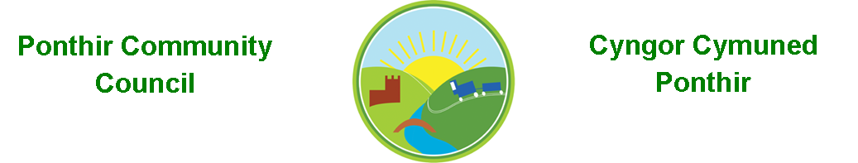
11th October 2021

Dear Councillor,
You are summoned to attend the Monthly Meeting to be held in accordance with the Coronavirus Regulations (Wales) 2020. Meeting is to be held on 11th October 2021 @ 7pm, Ponthir Sports and Community Club

Press and public welcome.
Mrs. Karen Kerslake

Agenda

- Present
- Apologies
- Declarations of Interest
- To consider matters raised by the members of the public present (N.B. Such matters will be reported upon by the Clerk at the next meeting, where appropriate)

- To approve the minutes of the meeting held on 13th September 2021

- Matters arising from the Monthly Meeting held on 13th September 2021
  - Complaint to Torfaen County Borough Council in relation to,
    - Tree maintenance
    - Drainage
    - Communication on proposed Local Development Plan and the suggestion of 1200 houses at Llanfrechfa Grange. Clerk to confirm receipt by TCBC – Deferred until next meeting.
  - Speeding in Ponthir/Crime & ASB – Deferred until inspector attends
  - SWALEC – Clerk to update
  - Community Garden – Clerk to resend schedule received from a potential contractor in a different format as there have been difficulties opening the document - Completed
  - Magazine articles – Clerk to circulate what we have in leaflet format in between meetings for all to agree – Completed
  - Communications – Promotion at events purchase some banners or pop-ups for use. Promote via Torfaen Comms Dept.- Clerk to update
  - Christmas Lights – Installation confirmed 2nd/3rd December.
  - PSCC Proposal – Agreed contribution not yet paid.
  - Christmas Tree and winter fayre – Two trees to be sited in the village, one at the usual spot by the community hall and another on ground to the rear of PSCC. Must be thirty feet above ground this year. Lights to be retrieved from contractor and trees ordered. Breakfast with Santa to be considered – Cllr Leighton to contact to see if he is available. John Parfitt confirmed Ponthir school and nursery are interested in involvement. Date proposed as after school on 3rd December for lighting of trees etc., winter fayre. More details needed to progress. Clerk to organize with PSCC representatives.
  - Benches in Ponthir – On agenda
  - Wildlife Pond – Clerk to update from PSCC and TCBC
  - Plaque to commemorate the visit of HRH to Ponthir House – Clerk to arrange
  - Cleaning of bus stops and bin.- Cllr Danaher will arrange for contract to start. Clerk will put up bus time tables once initial clean has been completed. Update required Cllr Danaher
  - Memorial Stone in Ponthir Church for remembrance. – Clerk will contact Church committee to discuss.
  - Emails are still problematic from Torfaen CBC – Clerk to update
  - Ponthir Hall – discussion

- Finance and Accounts

- Balance of Direct Plus Account as at 30th September 2021 £29,743.11

- Cheques/Online payments made
20.09.21 Poppy Shop £ 39.97
20.09.21 Zoom £143.88
- To Note Standing Order/Direct Debit Payments
20.09.21 Payroll £456.73
20.09.21 Swalec £ 23.76

- Quarterly Accounts – to be agreed.

- Budgets

- Wales Audit Office - Update

- Queen’s Platinum Jubilee – Discussion

- Benches - Discussion

- Planning Permission
Application for 5G mast has again been objected to in relation to the proposed location. PCC has forwarded a list of alternative sites to the developer.

- Any other Business

- To Note Correspondence Received
  - Planning app for 5G Mast Torfaen Planning
  - Gwent Valleys Area Committee meeting OVW
  - ABuHB – Covid Vaccine updates ABuHB
  - Ystadau Cymru Awards Welsh Government
  - Audit notice delay Wales Audit Office
  - Gwent WI Centenary Book WI
  - Parking on pavements Resident
  - Mirrors request opposite Hafod Rd Resident
  - Notification of elections 2022 TCBC
  - Various Newsletters TCBC/OVW/ABuHB

This document is available on our website www.ponthircommunitycouncil.gov.uk
A copy of this document could be made available in Welsh. Please contact us on the telephone number or e-mail below.
Mae dogfen yma yn ar gael mewn gwefan ni www.ponthircommunitycouncil.gov.uk Mae copi or ddogfen hon ar gael yn Gymraeg.
Cysylltwch a ni ar y rhif ffôn neu drwy e-bost isod.
Telephone/ Ffôn: 07789 640709 E-Mail/ E-bost: clerk@ponthircommunitycouncil.gov.uk

