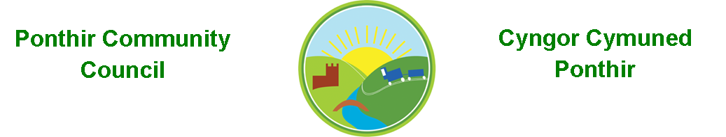
6th June 2021

Dear Councillor,
You are summoned to attend the Monthly Meeting to be held in accordance with the Coronavirus Regulations (Wales) 2020. Meeting is to be held on 12th July 2021 @ 7pm, Ponthir District Community Club

Press and public welcome.
Mrs. Karen Kerslake

Agenda

- Present
- Apologies
- Declarations of Interest
- To consider matters raised by the members of the public present (N.B. Such matters will be reported upon by the Clerk at the next meeting, where appropriate)

- To approve the minutes of the
  - Monthly Meeting held on 14th June 2021
  - AGM held on 14th June 2021

- Crime/ASB Report
- Matters arising from the Monthly Meeting held on 14th June 2021
  - Flooding/Drains/Potholes/Trees – Cllr Danaher to contact Andrew Osborne of TCBC in relation to the trees in the area and the recent report received from P Grimes.
  - Speeding in Ponthir – Torfaen Highways Department have confirmed that the average speed of vehicles is 24 mph through the village. This has followed a period of monitoring along the main road. Clerk to source price of speeding signage for both ends of the village.
  - SWALEC – Complaint to SWALEC has been made but monthly price of the service has increased to £20.35 per month.
  - Local Development Plan – nothing received from Torfaen
  - Community Garden – Latest price from a local contractor was considered excessive. Clerk to contact TCBC and Cllr Barrell is to contact another local contractor, A Skyrme for a quote. – Clerk to give update
  - Magazine articles – Agreed the timescales will be Autumn and Spring. Clerk to circulate what has already been done for the next meeting
  - Christmas Lights
    - Council agreed to purchase connections for nine lights throughout the village and ten lights to be purchased.
    - Clerk to write to M. Bowen about lights in Llanfrechfa village as LVA hasn’t responded to contact – there is the possibility of solar lights. Clerk will drop a letter in to Cllr Barrell who regularly passes M. Bowen’s address.
    - New stock catalogue to be obtained. Ponthir Junior School will also be asked to consider designs for recommendation.
    - Several designs to be considered and a variety of light designs to be ordered, possibly more bought than the nine connections to be determined.
    - Storage needs to be progressed – Cllr Danaher to investigate a one-year lease as an option for an identified location.
  - Wildlife Pond – Suggestions have been made to site the pond at the sports field. This will assist with drainage. TCBC to be contacted again for assistance – Clerk to give update
  - Cllr L Morgan to forward list of tasks including, maintenance of planting to Cllr Ryan-Scales who will approach the resident. These include,
    - Annual planting and maintenance around the village of planters
    - Painting of benches
    - Cleaning of bus stops
    - Cutting of grass around bench by Brechfa Farm and other areas.
  - Vacancy – Clerk to invite the prospective councillor to the next meeting – done
  - Proposal around more benches to be purchased cost of benches available and types – Clerk for next meeting.
  - Cllr H Bevan to be sent dates of future meetings.
  - Cllr Ryan-Scales to look at cost/organization of annual Bath trip.

- Finance and Accounts

- Balance of Direct Plus Account as at 30th June 2021 £29,150.72
- Bank Reconciliation Q1 - attached

- Cheques/Online payments made
02.06.21 Zurich Insurance £440.13
28.06.21 Internal Audit Fees £150.00
28.06.21 Planters - Acorn £560.00
- To Note Standing Order/Direct Debit Payments
21.06.21 Payroll £456.73
21.06.21 Swalec £19.95

- Planning Permission
No applications received

- Any other Business

- To Note Correspondence Received
  - Message from potential clients trying to book the Village Hall but experiencing problems in doing so.
  - Letter from resident re speeding.
  - Meeting planner and supporting documentation for Gwent Valleys Area meeting.
  - Correspondence from OVW in relation to London Bridge plans
  - Various emails from OVW wildlife spaces officer in relation to plans for PDCC grounds
  - Application for an account with SSE for street light connections
  - Email from Street Scene, TCBC in response to bin cleaning
  - Emails from WAO relating to the 2020/21 audit
  - Email from TCBC relating to invoicing.
  - Email from Henrietta Lucas, TCBC relating to quotes received for the community garden project.

This document is available on our website www.ponthircommunitycouncil.gov.uk
A copy of this document could be made available in Welsh. Please contact us on the telephone number or e-mail below.
Mae dogfen yma yn ar gael mewn gwefan ni www.ponthircommunitycouncil.gov.uk Mae copi or ddogfen hon ar gael yn Gymraeg.
Cysylltwch a ni ar y rhif ffôn neu drwy e-bost isod.
Telephone/ Ffôn: 07789 640709 E-Mail/ E-bost: clerk@ponthircommunitycouncil.gov.uk

