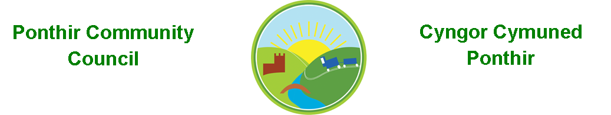
8th November 2021

Dear Councillor,
You are summoned to attend the Monthly Meeting to be held in accordance with the Coronavirus Regulations (Wales) 2020. Meeting is to be held on 8th November 2021 @ 6pm, Ponthir Sports and Community Club

Press and public welcome.
Mrs. Karen Kerslake

Agenda

- Present
- Apologies
- Declarations of Interest
- To consider matters raised by the members of the public present (N.B. Such matters will be reported upon by the Clerk at the next meeting, where appropriate)

- To approve the minutes of the meeting held on 11th October 2021
- Matters arising from the Monthly Meeting held on 11th October 2021
  - Complaint to Torfaen County Borough Council in relation to,
    - Tree maintenance
    - Drainage
    - Communication on proposed Local Development Plan and the suggestion of 1200 houses at Llanfrechfa Grange. - Update
  - Speeding in Ponthir – See attached communication
  - SWALEC – Disconnection at telephone box completed
  - Christmas Tree and winter fayre – Clerk to update
  - Parking on Hafod Road – No update from TCBC
  - Benches in Ponthir – Clerk
  - Wildlife Pond – PSCC Update
  - Cleaning of bus stops and bin.- Cllr Danaher
  - Memorial Stone in Ponthir Church for remembrance. - Clerk
  - 5G Mast – Planning application refused
  - Winter planting – completed
  - Queen’s platinum Jubilee – discussion/ideas

- Finance and Accounts

- Balance of Direct Plus Account as at 31st October 2021 £27,704.69

- Cheques/Online payments made
Newsletter £341.00
Western Power £418.98
PSCC Banners (August) £322.95
Acorn – winter planting £475.00

- To Note Standing Order/Direct Debit Payments
Payroll £456.73
Swalec £ 23.76

- Wales Audit Office – Update in final certificate

- Planning Permission

      - DEVELOPMENT PROPOSED: First floor rear extension over existing kitchen
LOCATION: Bridge Cottage, Caerleon Road, Ponthir
      - DEVELOPMENT PROPOSED: Erection of detached garage with integral office space to replace existing garage
LOCATION: Catoni, Candwr Road, Ponthir

- Any other Business

- To Note Correspondence Received

  - Letter (attached) Peter Fox AM
  - 5G Mast – alternative locations TCBC Planning
  - Gwent Valleys Area Committee OVW
  - Resident – drains
  - Resident – poppies and Christmas lights
  - Resident – alternative location of 5G Mast
  - Remembrance Services Ponthir Baptist Church
  - AM surgery notification Senedd Support
  - Planning applications (x2 above) TCBC Planning

This document is available on our website www.ponthircommunitycouncil.gov.uk
A copy of this document could be made available in Welsh. Please contact us on the telephone number or e-mail below.
Mae dogfen yma yn ar gael mewn gwefan ni www.ponthircommunitycouncil.gov.uk Mae copi or ddogfen hon ar gael yn Gymraeg.
Cysylltwch a ni ar y rhif ffôn neu drwy e-bost isod.
Telephone/ Ffôn: 07789 640709 E-Mail/ E-bost: clerk@ponthircommunitycouncil.gov.uk

