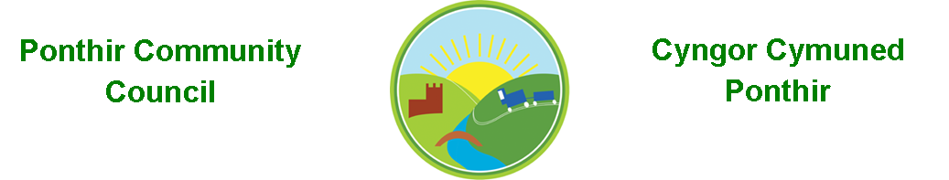
5th January 2022

Dear Councillor,
You are summoned to attend the Monthly Meeting to be held in accordance with the Coronavirus Regulations (Wales) 2020. Meeting is to be held on 10th January 2022 @ 7pm, via Zoom.

Press and public welcome.
Mrs. Karen Kerslake

Agenda

- Present
- Apologies
- Declarations of Interest
- To consider matters raised by the members of the public present (N.B. Such matters will be reported upon by the Clerk at the next meeting, where appropriate)

- To approve the minutes of the meeting held on 13th December 2021
- Matters arising from the Monthly Meeting held on 13th December 2021

  - Speeding in Ponthir – No progress with Torfaen County Borough Council or Gwent Police at present. Clerk to update
  - Wildlife Ponds and general work – PSCC Update .
  - Memorial Stone in Ponthir Church for remembrance. – Plans have been submitted by Ponthir Church. To be costed.
  - Queen’s platinum Jubilee – clerk to send email offering potential support for any events and bring those interested together.
    - Lighting of Beacons to commemorate event – information received from One Voice Wales
  - Survey for future Christmas Lights – Clerk to update
  - Report from TCBC – requested repairs to playground.

- Finance and Accounts

- Balance of Direct Plus Account as at 31st December 2021 £29,691.75

- Cheques/Online payments made
Festive Lighting £ 82.20
C. Mellen £1,860.00
JE Parfitt – bulbs £ 23.98
Microsoft Subs £ 59.99
Grant £ 100,00

- To Note Standing Order/Direct Debit Payments
Payroll £456.73
Swalec £ 8.82

- Quarterly Accounting Statement – deferred to February meeting

- Wales Audit Office – Update on final certificate.

- Local Government and Elections (Wales) Act 2021
  - Consultation and impact for Community Councils – Clerk to update.

- Precept Setting for 2022/23/Projects – Budget Discussion

- Planning Permission

None

- Any other Business

- To Note Correspondence Received
  - Queens Platinum Jubilee OVW (One Voice Wales)
  - Newsletters x 4 TCBC
  - Newsletter D. Davies MP
  - Revised PSCC Opening Times J Parfitt
  - May Council Elections Cwmbran Town Council
  - Village Hall Enquiries x 3
  - Gwent Valleys Area Meeting OVW
  - Newsletter Information Commissioner
  - Christmas Greetings Pontypool Town Council
  - Christmas Greetings High Sherriff of Gwent
  - Newsletter Vaccination Progress ABB (Aneurin Bevan HB)

This document is available on our website www.ponthircommunitycouncil.gov.uk
A copy of this document could be made available in Welsh. Please contact us on the telephone number or e-mail below.
Mae dogfen yma yn ar gael mewn gwefan ni www.ponthircommunitycouncil.gov.uk Mae copi or ddogfen hon ar gael yn Gymraeg.
Cysylltwch a ni ar y rhif ffôn neu drwy e-bost isod.
Telephone/ Ffôn: 07789 640709 E-Mail/ E-bost: clerk@ponthircommunitycouncil.gov.uk

