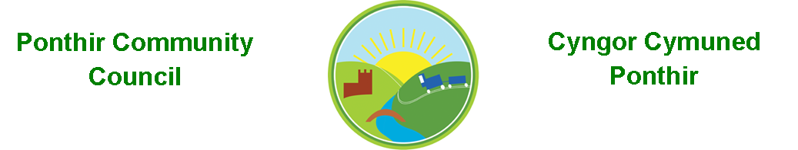
4th May 2022

Dear Councillor,
You are summoned to attend the Monthly Meeting to be held on 9th May 2022 @ 7pm, in PSCC.

Press and public welcome.
Mrs. Karen Kerslake

Agenda

- Present
- Apologies
- Declarations of Interest
- To consider matters raised by the members of the public present (N.B. Such matters will be reported upon by the Clerk at the next meeting, where appropriate)

- To approve the minutes of the meeting held on 11th April 2022

- Matters arising from the Monthly Meeting held on 11th April 2022
  - Speeding in Ponthir
  - Update on work with David Leach, TCBC
  - Update on work with PSCC
  - Memorial Stone in Ponthir Church for remembrance. – Proposal attached – Decision
  - Benches
  - Survey for future Christmas Lights
  - Hall Committee update
  - General Contractor
  - Newsletter
  - Playground fencing

- Provision for Future Community Events
  - Marquees
  - Inflatable outdoor screens
  - Support for children’s event on 4th June – Jubilee
  - Future joint working with PSCC around events
    - August bank holiday music event
    - Christmas lights and tree event planning

- Finance and Accounts

- Balance of Direct Plus Account as at 30st April 2022 £25,596.04

- To Note Invoices Paid
CA Danaher £ 9.99
Community Times £ 80.00
Wales Seniors Cricket £ 150.00
One Voice Wales £ 224.00
Torfaen CBC £ 147.00
Acorn Garden Services £ 230.00

- To Note Standing Order/Direct Debit Payments
Payroll £ 456.73

- Planning Permission
None received for April.

- Any other Business

- To Note Correspondence Received
  - Newsletters x 4 TCBC
  - Survey Wales Audit Office
  - Reminder for payment OVW
  - Invoice – room hire PSCC
  - Christmas Lights Enerveo
  - Audit requirements 2021/22 Wales Audit Office
  - Land ownership SSE
  - Local Places for Nature OVW
  - All Saints Church – Jubilee A. O’Brian
  - 5G Mast TCBC, Planning

This document is available on our website www.ponthircommunitycouncil.gov.uk
A copy of this document could be made available in Welsh. Please contact us on the telephone number or e-mail below.
Mae dogfen yma yn ar gael mewn gwefan ni www.ponthircommunitycouncil.gov.uk Mae copi or ddogfen hon ar gael yn Gymraeg.
Cysylltwch a ni ar y rhif ffôn neu drwy e-bost isod.
Telephone/ Ffôn: 07789 640709 E-Mail/ E-bost: clerk@ponthircommunitycouncil.gov.uk

