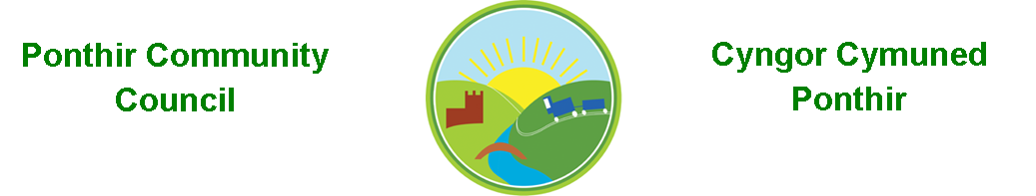
4th May 2022

Dear Councillor,
You are summoned to attend the Monthly Meeting to be held on 13th June 2022 @ 7pm, in PSCC.

Press and public welcome.
Mrs. Karen Kerslake

Agenda

- Present
- Apologies
- Declarations of Interest
- To consider matters raised by the members of the public present (N.B. Such matters will be reported upon by the Clerk at the next meeting, where appropriate)

- To approve the minutes of the meeting held on 9th May 2022 and AGM of same date.
- Matters arising from the Monthly Meeting held on 9th May 2022
  - Speeding signage in Ponthir
  - Provision for future events
    - August Bank Holiday
    - Christmas Lighting Event
    - Equipment – Inflatable screens
  - Memorial Stone in Ponthir Church for remembrance.
  - Benches
  - Survey for future Christmas Lights
  - Ponthir School Parking
  - Hall Committee update
  - General Contractor
  - Newsletter

- Engagement on Community Council’s Main Wellbeing Priorities
  - Drain schedule
  - Trees at Oaklands – Meeting with Chief Officer scheduled for 16th June 2022 at 6pm, PSCC – all residents welcome.
  - Wellbeing project – AbuHB
  - Any other suggestions

- Code of Conduct

- Advertising of Clerk’s Post

- Website

- Finance and Accounts
- Balance of Direct Plus Account as at 31st May 2022 £21,973.08

- To Note Invoices Paid
HCI Data £ 50.10
One Voice Wales £ 215.00
PSCC – Room Hire £ 240.00
Newsletter £ 387.00
PSCC – Marquees £1658.00
Currys – Printer Ink £ 54.99
Acorn – Planters £ 540.00

- To Note Standing Order/Direct Debit Payments
Payroll £ 456.73
Adobe £ 21.14

- Agree the Annual Return to Wales Audit Office for 2021/22

- Planning Permission
DEVELOPMENT PROPOSED: Two storey extension to rear, porch to front and additional parking space (amended from approved scheme
21/P/0983/HH)
LOCATION: 8 Lamb Lane, Ponthir, Cwmbran

- Any other Business

- To Note Correspondence Received
  - Invoice Zurich Insurance
  - Newsletters x 4 TCBC
  - Training x 4 One Voice Wales
  - Closed roads in Torfaen TCBC
  - Memorial Order E J Herbert
  - Various emails re Jubilee PSCC

This document is available on our website www.ponthircommunitycouncil.gov.uk
A copy of this document could be made available in Welsh. Please contact us on the telephone number or e-mail below.
Mae dogfen yma yn ar gael mewn gwefan ni www.ponthircommunitycouncil.gov.uk Mae copi or ddogfen hon ar gael yn Gymraeg.
Cysylltwch a ni ar y rhif ffôn neu drwy e-bost isod.
Telephone/ Ffôn: 07789 640709 E-Mail/ E-bost: clerk@ponthircommunitycouncil.gov.uk

