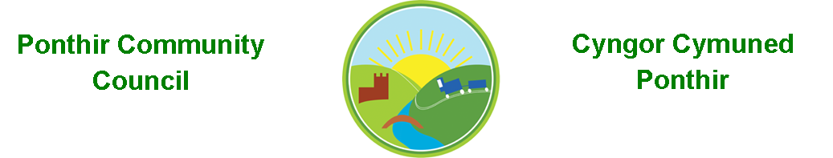
6th July 2022

Dear Councillor,
You are summoned to attend the Monthly Meeting to be held on 11th July 2022 @ 7pm, in PSCC.

Press and public welcome.
Mrs. Karen Kerslake

Agenda

- Present
- Apologies
- Declarations of Interest
- To consider matters raised by the members of the public present (N.B. Such matters will be reported upon by the Clerk at the next meeting, where appropriate)

- To approve the minutes of the meeting held on 13th June 2022
- Matters arising from the Monthly Meeting held on 13th June 2022
  - Speeding signage in Ponthir – No update at this time
  - Provision for future events
    - August Bank Holiday -
    - Christmas Lighting Event
    - Equipment – Inflatable screens
  - Benches – still awaiting permissions from Torfaen.
  - Christmas Lights – informal proposal attached.
  - Ponthir School Parking – No update at this time.
  - Hall Committee update
  - General Contractor – Clerk to update
  - Clerk’s post
  - Jubilee Coins for school pupils – completed
  - Bath trip – Cllr Ryan-Scales to update
  - Update on recent meetings re trees in Oaklands – Cllr Danaher
  - Website rebuild
  - Additional crossing in Ponthir – Clerk

- Planters in Ponthir
- Grants
  - A Bubella Fitness
  - Fosse Wine Society

- Finance and Accounts
- Balance of Direct Plus Account as at 30st June 2022 £19,720.89

- To Note Invoices Paid
  - Internal Audit Fee £150.00
  - Insurance – Zurich £445.46
  - EJ Herbert Deposit £1,200.00

- To Note Standing Order/Direct Debit Payments
  - Clerks’ Salary £456.73

- Planning Permission
  - None

- Any other Business

- To Note Correspondence Received
  - Church remembrance stone E J Herbert
  - Levelling up project TCBC
  - Newsletters x 4 TCBC
  - Training opportunities OVW
  - ABuHB Newsletter ABuHB
  - Council and Cabinet Agendas TCBC
  - Volunteering TVA
  - Quotation Enerveo

This document is available on our website www.ponthircommunitycouncil.gov.uk
A copy of this document could be made available in Welsh. Please contact us on the telephone number or e-mail below.
Mae dogfen yma yn ar gael mewn gwefan ni www.ponthircommunitycouncil.gov.uk Mae copi or ddogfen hon ar gael yn Gymraeg.
Cysylltwch a ni ar y rhif ffôn neu drwy e-bost isod.
Telephone/ Ffôn: 07789 640709 E-Mail/ E-bost: clerk@ponthircommunitycouncil.gov.uk

