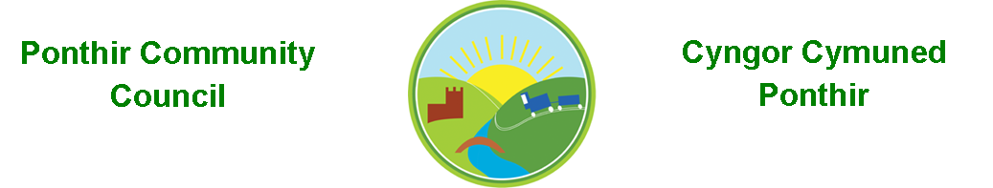
7th September 2022

Dear Councillor,
You are summoned to attend the Monthly Meeting to be held on 12th September 2022 @ 7pm, in PSCC.

Press and public welcome.
Mrs. Karen Kerslake

Agenda

- Present
- Apologies
- Declarations of Interest
- To consider matters raised by the members of the public present (N.B. Such matters will be reported upon by the Clerk at the next meeting, where appropriate).

- To approve the minutes of the meeting held on 11th July 2022
- Matters arising from the Monthly Meeting held on 11th July 2022
  - Speeding signage in Ponthir
  - Benches
  - Christmas Lights
  - Ponthir School Parking
  - Hall Committee update
  - General Contractor
  - Clerk’s post
  - Jubilee Coins for school pupils
  - Bath trip – Cllr Ryan-Scales to update
  - Website rebuild
  - Additional crossing in Ponthir – Clerk
  - Planters in village

- Progress on Matters Outstanding with TCBC
  - Wellbeing
  - Oaklands
  - Drainage works (plan)
- Update – Cllr Gauden

- Finance and Accounts
- Balance of Direct Plus Account as at 31st August 2022 £24,675.73

- To Note Invoices Paid – July/August
  - Acorn Garden Services £240.00
  - Torfaen CBC Payroll £ 65.95
  - Torfaen CBC Payroll £ 47.00
  - Torfaen CBC Payroll £ 47.00
  - Torfaen CBC Payroll £ 47.00
  - Torfaen CBC Payroll £ 31.90
  - Torfaen CBC Payroll £ 65.95
  - Torfaen CBC Payroll £ 31.90

- To Note Standing Order/Direct Debit Payments
  - Clerk - Salary £456.73
  - Clerk – Salary £456.73
  - ICO £ 35.00

- Planning Permission
  - DEVELOPMENT PROPOSED: Proposed demolition of garage and erection of side extension, raising of roof pitch and new dormers and change to external facing materials
LOCATION: Teliro, Tram Lane, Llanfrechfa
  - Proposed development Delerwyn House, Lamb Lane – Planning Application – Cllr Lorraine Morgan

- Any other Business

- To Note Correspondence Received
  - 5G Mast Appeal Torfaen CBC
  - Newsletters x 8 Torfaen CBC
  - Newsletters x 4 ` ABuHB
  - Training opportunities One Voice Wales
  - Letter to Torfaen re parking PSCC
  - Comments on speeding Residents x 2
  - Invoice HCI Data
  - Theft – Hafod Road Resident
  - Grant funding Torfaen CBC/OVW

This document is available on our website www.ponthircommunitycouncil.gov.uk
A copy of this document could be made available in Welsh. Please contact us on the telephone number or e-mail below.
Mae dogfen yma yn ar gael mewn gwefan ni www.ponthircommunitycouncil.gov.uk Mae copi or ddogfen hon ar gael yn Gymraeg.
Cysylltwch a ni ar y rhif ffôn neu drwy e-bost isod.
Telephone/ Ffôn: 07789 640709 E-Mail/ E-bost: clerk@ponthircommunitycouncil.gov.uk

