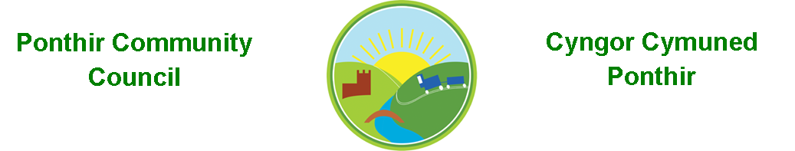
3rd December 2022

Dear Councillor,
You are summoned to attend the Monthly Meeting to be held on Monday 12th December 2022 @ 7pm, in PSCC.

Press and public welcome.
Mrs. Clare Danaher

Agenda
- Present
- Apologies
- Declarations of Interest
- To consider matters raised by the members of the public (N.B. Such matters will be reported upon by the Clerk at the next meeting, where appropriate).

- To approve the minutes of the meeting held on 14th November 2022
- Matters arising from the Monthly Meeting held on 14th November 2022
  - Speeding signage in Ponthir.
  - Christmas lights/trees/fair.
  - Hall Committee update
  - General contractor update
  - Bath trip.
  - Website update.
  - Bus shelters.
  - Budgets 2023.

- Progress on Matters Outstanding with TCBC
  - Wellbeing.

- Finance and Accounts
- Balance of Direct Plus Account as at 30th November 2022 £18,727.64
- To Note Invoices Paid – November

- 1 NOV TORFAEN CBC £552.43

- 10 NOV Amazon £ 86.37
Page 1 of 2

- 11 NOV Stamps £ 8.16
- 11 NOV Clerk Phone £ 18.00
- 11 NOV Royal British Legion £357.50
- 11 NOV Keepings Coaches £550.00
- 14 NOV Amazon £ 57.98
- 21 NOV Torfaen CBC K KERSLAKE £456.73
- 22 NOV Phone Charger £ 10.99
- 22 NOV Fosse Wine Grant £ 50.00

- 28 NOV BOOKER Limited £ 98.94
- 28 NOV 1st Ponthir Brownies £100.00
- 28 NOV Banners £166.65
- 28 NOV Torfaen CBC £ 520.53

- Planning Permission
None

- Any other Business

- To Note Correspondence Received
  - Newsletters x 10 Torfaen CBC
  - Newsletters x 8 Others
  - Training opportunities One Voice Wales & SLCC
  - Grant application 1st Ponthir Rainbows
  - Village Carol Concert

This document is available on our website www.ponthircommunitycouncil.gov.uk
A copy of this document could be made available in Welsh. Please contact us on the telephone number or e-mail below.
Mae dogfen yma yn ar gael mewn gwefan ni www.ponthircommunitycouncil.gov.uk Mae copi or ddogfen hon ar gael yn Gymraeg.
Cysylltwch a ni ar y rhif ffôn neu drwy e-bost isod.
Telephone/ Ffôn: 07454 988250 E-Mail/ E-bost: clerk@ponthircommunitycouncil.gov.uk

Page 2 of 2

