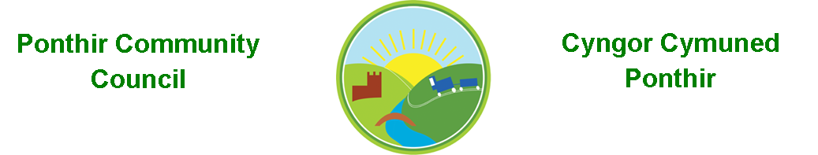
3rd November 2022

Dear Councillor,
You are summoned to attend the Monthly Meeting to be held on 14th November 2022 @ 7pm, in PSCC.

Press and public welcome.
Mrs. Clare Danaher

Agenda

- Present
- Apologies
- Declarations of Interest
- To consider matters raised by the members of the public (N.B. Such matters will be reported upon by the Clerk at the next meeting, where appropriate). .

- To approve the minutes of the meeting held on 10th October 2022
- Matters arising from the Monthly Meeting held on 10th October 2022
  - Speeding signage in Ponthir.
  - Christmas lights/trees/fair.
  - Hall Committee update
  - General contractor/ strimmer purchase.
  - Bath trip.
  - Website update
  - Planters in village
  - Newsletter
  - Footpath sign
  - Bus shelters
  - Streetlights School Close
  - Ponthir Road drain cover.
  - Plaque James Ball Cyclist
  - Armed Forces Day
  - Community Facilities meeting

- Progress on Matters Outstanding with TCBC
  - Wellbeing
  - Oaklands
  - Drainage works update
  - Additional crossing in Ponthir

- Finance and Accounts
- Balance of Direct Plus Account as at 30th September 2022 £22,302.44

- To Note Invoices Paid – July/August
  - Garage rental £ 720.00
  - HCI Data Ltd £ 153.30
  - Tower Mint £ 406.68
  - Blakemore retail £ 5.44
  - Keepings Coaches £ 50.00
  - Zoom rental £ 143.88
  - Torfaen CBC Payroll £ 405.36
  - Torfaen CBC Payroll £ 31.90

- To Note Standing Order/Direct Debit Payments
  - Clerk - Salary £456.73

- Planning Permission
  - Single story extension at Stokes Court Ponthir – Planning Application noted by Council - no objections.

- Any other Business

- To Note Correspondence Received
  - Newsletters x 6 Torfaen CBC
  - Newsletters x 4` Others
  - Training opportunities One Voice Wales & SLCC
  - Marquee rental Resident
  - Community Council Review Torfaen CBC
  - Plaque James Ball Cyclist Resident
  - Armed Forces Day Torfaen CBC
  - Community Facilities meeting PSCC

This document is available on our website www.ponthircommunitycouncil.gov.uk
A copy of this document could be made available in Welsh. Please contact us on the telephone number or e-mail below.
Mae dogfen yma yn ar gael mewn gwefan ni www.ponthircommunitycouncil.gov.uk Mae copi or ddogfen hon ar gael yn Gymraeg.
Cysylltwch a ni ar y rhif ffôn neu drwy e-bost isod.
Telephone/ Ffôn: 07789 640709 E-Mail/ E-bost: clerk@ponthircommunitycouncil.gov.uk

