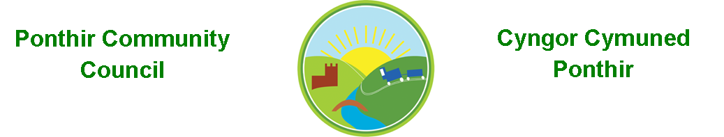
29th December 2022

Dear Councillor,
You are summoned to attend the Monthly Meeting to be held on Monday 9th January 2023 @ 7pm, in PSCC.

Press and public welcome.
Mrs. Clare Danaher

Agenda
- Present
- Apologies
- Declarations of Interest
- To consider matters raised by the members of the public (N.B. Such matters will be reported upon by the Clerk at the next meeting, where appropriate).

- To approve the minutes of the meeting held on 12th December 2022.
- Matters arising.
  - Christmas lights 2023.
  - Village Hall.
  - General contractor.
  - Council Procedures and Website.
  - Bus shelters and bus stops.
  - Budgets 2023.
  - Marque lettings.
  - Meeting dates 2023.
  - PSCC presentation.

- Progress on Matters Outstanding with TCBC
  - Wellbeing.
  - Meeting with Leader of TCBC, Cllr Anthony Hunt.

- Finance and Accounts
- Balance of Direct Plus Account as at 20th December 2022 £15,770.92

Page 1 of 2

To Note Invoices Paid – December

Torfaen CBC £456.73
Microsoft £59.99
Torfaen CBC £650.00
C R Mellen £1,790.00

- Planning Permission
Correction of existing access to Byways, Caerleon Rd, Ponthir.

- Any other Business

- To Note Correspondence Received
  - Newsletters x 18 TCBC
  - Newsletters x 11 Others
  - One Voice Wales x10
  - Health Board x 7

This document is available on our website www.ponthircommunitycouncil.gov.uk
A copy of this document could be made available in Welsh. Please contact us on the telephone number or e-mail below.
Mae dogfen yma yn ar gael mewn gwefan ni www.ponthircommunitycouncil.gov.uk Mae copi or ddogfen hon ar gael yn Gymraeg.
Cysylltwch a ni ar y rhif ffôn neu drwy e-bost isod.
Telephone/ Ffôn: 07454 988250 E-Mail/ E-bost: clerk@ponthircommunitycouncil.gov.uk

Page 2 of 2

