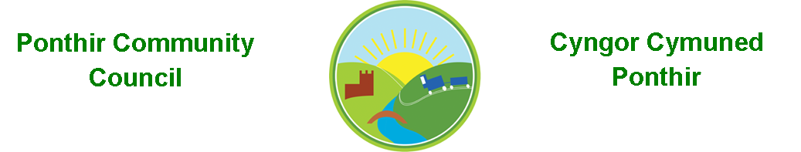
2nd February 2023

Dear Councillor,
You are summoned to attend the Monthly Meeting to be held on Monday 13th February 2023 @ 7pm, in PSCC.

Press and public welcome.
Mrs. Clare Danaher

Agenda
- Present
- Apologies
- Declarations of Interest
- To consider matters raised by the members of the public, to include PSCC presentation, J Parfitt. (Relevant matters will be reported upon by the Clerk at the next meeting, where appropriate).

- To approve the minutes of the meeting held on 9th January 2023.
- Matters arising
  - Christmas lights 2023.
  - Village Hall.
  - Council Procedures.
  - Bus shelters, bus stops and timetables.
  - Marque lettings.
  - Cost of elections.
  - Training.

- Progress on Matters Outstanding with TCBC
  - Wellbeing.
  - Opening Doors Connecting Torfaen.
  - School Close parking.

- To consider and discuss items.
  - Clerk’s contract/SLCC.
  - HCI Data, laptop, printer, and website.
  - Community Council Events.
  - Grant applications.
  - Walled Garden and spring planters. Page 1 of 2
  - Newsletter/Photography competition.

Finance and Accounts

Balance of Direct Plus Account as at 31st January 2023 £20,976.50

To Note Invoices Paid – January

Chocolates/L Ash 5.00
Paper/Wilko 7.00
WordPress Book 10.52
Stationery/Sainsburys 12.37
Clerk Phone (December) 18.00
SLCC Course 24.00
SLCC Membership 149.00
Torfaen CBC 650.00
1st Ponthir Rainbows 100.00
Michael R Lyons 160.00
Clerk Phone (January) 18.00
Torfaen CBC 75.25
Timpson Ltd 13.30
Amazon Post box 31.98

- Planning Permission
None

- Any other Business

- To Note Correspondence Received
  - Newsletters x 18 TCBC
  - Newsletters x 38 Others
  - One Voice Wales x20
  - Health Board x 7

This document is available on our website www.ponthircommunitycouncil.gov.uk
A copy of this document could be made available in Welsh. Please contact us on the telephone number or e-mail below.
Mae dogfen yma yn ar gael mewn gwefan ni www.ponthircommunitycouncil.gov.uk Mae copi or ddogfen hon ar gael yn Gymraeg.
Cysylltwch a ni ar y rhif ffôn neu drwy e-bost isod.
Telephone/ Ffôn: 07454 988250 E-Mail/ E-bost: clerk@ponthircommunitycouncil.gov.uk

Page 2 of 2

