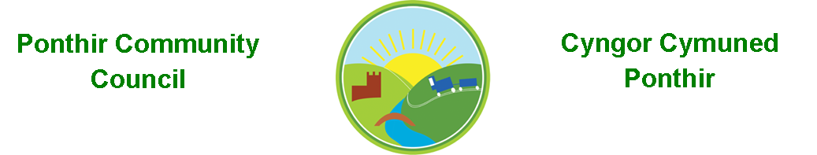
2nd March 2023

Dear Councillor,
You are summoned to attend the Monthly Meeting to be held on Monday 13th March 2023 @ 7pm, in PSCC.

Press and public welcome.
Mrs. Clare Danaher

Agenda
- Present
- Apologies
- Declarations of Interest
- To consider matters raised by the members of the public.
- To approve the minutes of the meeting held on 13th February 2023.
- Matters arising
  - Christmas lights 2023.
  - Council Procedures.
  - Bus shelters, bus stops and timetables.
  - Cost of elections.
  - Training.
  - Clerk’s contract.
  - Community Council events.
  - Grant applications.
  - Newsletter.
  - Debris in river.
  - Park fences update.

- TCBC matters arising
  - Wellbeing.
  - Opening Doors Connecting Torfaen - presentation.

- To consider and discuss items.
  - Christmas Fayre
  - Old laptop and records.

Page 1 of 2

Finance and Accounts

Balance of Direct Plus Account as of 28th February 2023 £16,167.98

To Note Invoices Paid – February

Microsoft Office Pro 119.99
Microsoft PC upgrade 11.28
Address Book 3.99
Currys USB Sticks 29.98
Michael R Lyons 185.00
Magnox filing cabinet 30.00
We Fix Your PC 300.00
Stuart Howells bus stop cleaning 530.00
Torfaen CBC 650.00
Walled Garden planter deposit 100.00
Walled Garden grant 200.00
Table Tennis Club grant 200.00
Enerveo 2022 Christmas Lights 2,177.28
Raffle Prize 10.00
Clerk Phone 18.00
One Voice Wales Membership 23/24 243.00

- Planning Permission
None

- Any other Business

- To Note Correspondence Received
  - Newsletters x 31 TCBC
  - Newsletters x 71 Others
  - One Voice Wales x 17
  - Health Board x 2
  - Letters of thanks re Grants x2
  - Other Community Councils x2

This document is available on our website www.ponthircommunitycouncil.gov.uk
A copy of this document could be made available in Welsh. Please contact us on the telephone number or e-mail below.
Mae dogfen yma yn ar gael mewn gwefan ni www.ponthircommunitycouncil.gov.uk Mae copi or ddogfen hon ar gael yn Gymraeg.
Cysylltwch a ni ar y rhif ffôn neu drwy e-bost isod.
Telephone/ Ffôn: 07454 988250 E-Mail/ E-bost: clerk@ponthircommunitycouncil.gov.uk
Page 2 of 2

