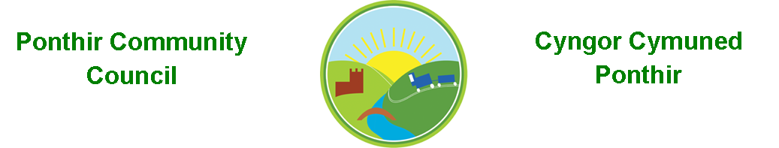
25th March 2023

Dear Councillor,
You are summoned to attend the Monthly Meeting to be held on Monday 3rd April 2023 @ 7pm, in PSCC.

Press and public welcome.
Mrs. Clare Danaher Clerk PCC

Agenda
- Present
- Apologies
- Declarations of Interest
- TCBC Matters
a. Community Review - Caroline Genever-Jones.
b. Waste and Recycling Consultation - Katie Jenkins.
- To approve the minutes of the meeting held on 13th March 2023.
- Matters arising.
  - Council Procedures.
  - Training.
  - Community Council events.
  - Newsletter.
  - Debris in river.
  - Park fences update.

- To consider matters raised by the members of the public.

- To consider and discuss items.
  - Christmas Fayre.
  - 20 mph speed limit.
  - PSCC developments and planning.
  - Ponthir litter pick - Karl Gauden.
  - Memorial stone dedication.

Page 1 of 2

Finance and Accounts

Balance of Direct Plus Account as of 24th March 2023 £14,825.16

To Note Invoices Paid – to 24th March 2023

Microsoft £ 11.28
Llanfrechfa PCC Grant £200.00
1st Ponthir Guides Grant £200.00
Clerk Phone £ 18.00
Torfaen CBC £650.00
Ponthir WI Grant £200.00
Wilko £ 8.90

- Planning Permission

None

- Any other Business

- To Note Correspondence Received
  - TCBC x 26
  - Others x 57
  - One Voice Wales x 18
  - Health Board x 3
  - Letter of thanks from WI re grant

This document is available on our website www.ponthircommunitycouncil.gov.uk
A copy of this document could be made available in Welsh. Please contact us on the telephone number or e-mail below.
Mae dogfen yma yn ar gael mewn gwefan ni www.ponthircommunitycouncil.gov.uk Mae copi or ddogfen hon ar gael yn Gymraeg.
Cysylltwch a ni ar y rhif ffôn neu drwy e-bost isod.
Telephone/ Ffôn: 07454 988250 E-Mail/ E-bost: clerk@ponthircommunitycouncil.gov.uk
Page 2 of 2

