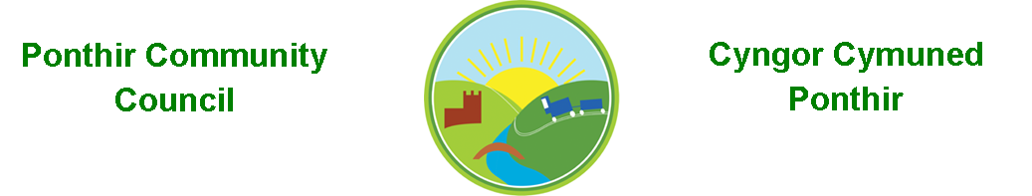
2nd May 2023

Dear Councillor,
You are summoned to attend the Annual General Meeting. Meeting is to be held on 9th May 2023 at 7.00pm at the PSCC.

Press and public welcome.
Mrs. Clare Danaher Clerk to the Council.

Agenda

- Present
- Apologies
- Election of Chair
- Election of Vice-Chair

- Declarations of Interest

- Chairman’s Annual Report.

- Date of monthly meetings up to May 2024

- Election of Representatives to,
  - Ponthir Church in Wales School
  - Torfaen County Association of Local Councils (TCALC)
  - Gwent Valleys Partnership
  - PDSC
  - Ponthir Village Hall.
  - Any other Committees.

This document is available on our website www.ponthircommunitycouncil.gov.uk
A copy of this document could be made available in Welsh. Please contact us on the telephone number or e-mail below.
Mae dogfen yma yn ar gael mewn gwefan ni www.ponthircommunitycouncil.gov.uk Mae copi or ddogfen hon ar gael yn Gymraeg.
Cysylltwch a ni ar y rhif ffôn neu drwy e-bost isod.
Telephone/ Ffôn: 07454 988250 E-Mail/ E-bost: clerk@ponthircommunitycouncil.gov.uk

