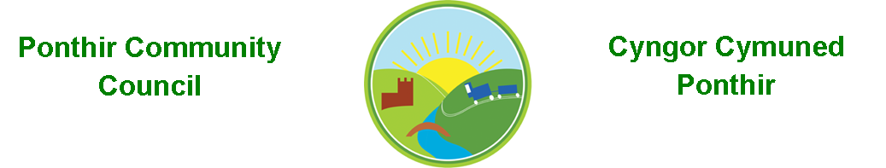
3rd July 2023

Dear Councillor,
You are summoned to attend the Monthly Meeting to be held on Monday 10th July 2023 @ 7pm, in PSCC.

Should anyone wish to access the meeting remotely, please contact the Clerk, at least three working days prior to the meeting.

Press and public welcome.
Mrs. Clare Danaher Clerk PCC

Agenda
- Present
- Apologies
- Declarations of Interest
- TCBC Guests, Dave Leech and Jo Harris.
- To consider matters raised by the members of the public.

- To approve the minutes of the meeting held on 12th June 2023.
- Matters arising.
  - Council Procedures ratification.
  - Training.
  - Newsletter.
  - Christmas Fayre.
  - Memorial stone/dedication.
  - Planters.
  - Election.
  - Zoom account.

7.To consider and discuss items.
a. Grant applications.
b. Candwr Park grassland.
c. Three monthly account audit.

Page 1 of 2

8. Finance and Accounts

Balance of Direct Plus Account as of 30th June 2023 £16,375.35

To Note Invoices Paid And Credits Received – to 30th June 2023

31st May TCBC £650.00
31st May Zurich Insurance £570.00
14th June Davies Printing £478.00
20th June Stamps £ 12.00
20th June Clerk Phone £ 18.00
26th June Currys Ink £ 28.49
26th June OVW Training £ 76.00
26th June Works Stationery £ 6.00
26th June TCBC £752.35
28th June Walled Garden Planters £400.00

Cooperative Bank Complaint £25.00cr

9. Planning

Proposed extension 13 The Orchard, Ponthir.

10. To Note Correspondence Received
TCBC x 31
Others x 65
One Voice Wales x 27
Health Board x 5

11. Committee Reports

- Ponthir Church in Wales Primary School.
- Torfaen County Association of Local Councils.
- Gwent Valleys Partnership.
- Ponthir Village Hall.
- PSCC.

This document is available on our website www.ponthircommunitycouncil.gov.uk
A copy of this document could be made available in Welsh. Please contact us on the telephone number or e-mail below.
Mae dogfen yma yn ar gael mewn gwefan ni www.ponthircommunitycouncil.gov.uk Mae copi or ddogfen hon ar gael yn Gymraeg.
Cysylltwch a ni ar y rhif ffôn neu drwy e-bost isod.
Telephone/ Ffôn: 07454 988250 E-Mail/ E-bost: clerk@ponthircommunitycouncil.gov.uk
Page 2 of 2

