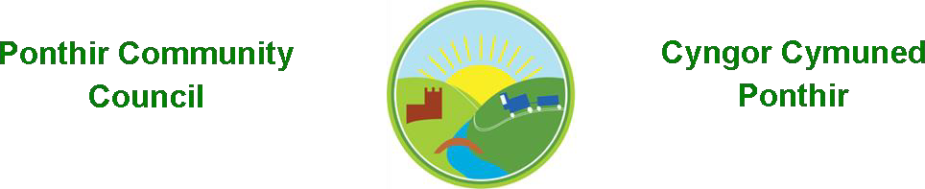
- 6 new benches sited in the village.
- 2 marquees purchased by Council for benefit of the community and used for the first time at the PSCC’s Jubilee party in June.
- Jubilee crowns provided to all pupils at Ponthir Church in Wales School.
- Reaffirmation of the Conferment of The Freedom of the County Borough of Torfaen upon The Royal Welsh Regiment attended by the Chair.
- New Clerk to the Council appointed in September.
- Army Covenant signed by the Chair on behalf of the Council.
- Remembrance Day services attended at Ponthir Baptist and All Saints Llanfrechfa Churches. Wreaths provided by Council.
- Poppies on lampposts in the village extended to Lower Llanfrechfa.
- Bath Christmas Markets coach trip.
- 3 Christmas trees in the village provided by Council.
- Village tree lighting and Christmas Fayre supported by Council.
- Christmas lights on lamp posts in the village again.
- Village Carol Service.
- Ponthir and Llanfrechfa Health and Wellbeing Community survey.
- Cwmbran Community Council Dinner attended by Chair.
- Army Engagement Reception at Rodney Parade attended by Chair.
Ian Danaher Chair 2022/23

