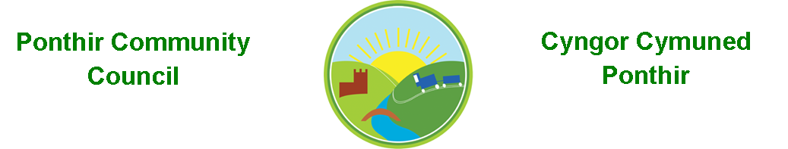
1st September 2023

Dear Councillor,
You are summoned to attend the Monthly Meeting to be held on Monday 11th September 2023 @ 7pm at the PSCC.

Should anyone wish to access the meeting remotely, please contact the Clerk, at least three working days prior to the meeting.

Press and public welcome.
Mrs. Clare Danaher Clerk PCC

Agenda
- Present
- Apologies
- Declarations of Interest
- To consider matters raised by the members of the public

- To approve the minutes of the meeting held on 10th July 2023
- Matters arising
  - Bio-Diversity Plan
  - Training
  - Christmas Fayre
  - Memorial stone/dedication
  - Election.
  - Zoom account
  - Grant applications
  - Table Tennis Club

7. To consider and discuss items
a. Christmas trees and lights
b. WAG/20mph campaign
c. Poppies
d. RLDP
e. Meeting venue
f. Gwent Police
g. Mick Morris Memorial Sporting Trust
Page 1 of 2

8. Finance and Accounts

Balance of Direct Plus Account as of 31st July 2023 £16,276.96

To Note Invoices Paid and Credits Received – to 31st July 2023

Microsoft 11.28
ADOBE Reader 19.97
Expenses 150.00
One Voice Wales Training 38.00
Cwmbran CC Donation 100.00
Clerk Phone 19.00
TCBC 805.00

Clerk Phone Refund 18.00
VAT Refund 22/23 1026.86

To Note Invoices Paid and Credits Received – to 31st August 2023

Microsoft 11.28
Adobe 19.97
Garage Rental 23/24 756.00
HCI Data Ltd 16.80
TCBC 1,850.53
PSCC Rent 200.00
Currys 54.98
Expenses 150.00
ICO Subscription 35.00
Amazon Ink cartridges 31.07
Wefixyourpc 75.00

Clerk Phone 19.00
TCBC 805.00

TCBC Precept Credit 6,480.00

Balance of Direct Plus Account as of 31st August 2023 £18,732.33

9. Planning

Several crown reductions, re pollarding, foliage lifting, removal of ivy.
2 fellings and replacements 6 Hafod Gardens Ponthir.

Page 2 of 3
10. To Note Correspondence Received
TCBC x 56
Others x 77
One Voice Wales x 40
Health Board x 17

11. Committee Reports

- Ponthir Church in Wales Primary School.
- Torfaen County Association of Local Councils.
- Gwent Valleys Partnership.
- Ponthir Village Hall.
- PSCC.

This document is available on our website www.ponthircommunitycouncil.gov.uk
A copy of this document could be made available in Welsh. Please contact us on the telephone number or e-mail below.
Mae dogfen yma yn ar gael mewn gwefan ni www.ponthircommunitycouncil.gov.uk Mae copi or ddogfen hon ar gael yn Gymraeg.
Cysylltwch a ni ar y rhif ffôn neu drwy e-bost isod.
Telephone/ Ffôn: 07454 988250 E-Mail/ E-bost: clerk@ponthircommunitycouncil.gov.uk
Page 3 of 3

