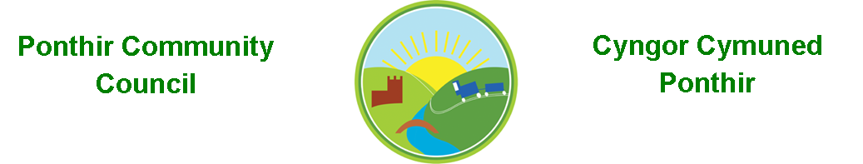
1st October 2023

Dear Councillor,
You are summoned to attend the Monthly Meeting to be held on Monday 9th October 2023 @ 7pm at the PSCC.

Should anyone wish to access the meeting remotely, please contact the Clerk, at least three working days prior to the meeting.

Press and public welcome.
Mrs. Clare Danaher Clerk PCC

Agenda
- Present
- Apologies for absence (To be agreed by Councilor’s present)
- Declarations of Interest
- To consider matters raised by the members of the public

- To approve the minutes of the meeting held on 11th September 2023
- Matters arising
  - Bio-Diversity Plan
  - Training
  - Christmas Fayre
  - Memorial stone/dedication
  - Christmas trees and lights
  - WAG/20mph campaign
  - Poppies
  - Meeting venue
  - Gwent Police
  - Mick Morris Memorial Sporting Trust
  - RLDP
  - Candwr Park grass area
  - Grant applications/ defib course
  - Table Tennis Club
  - Community Review

Page 1 of 3

7. To consider and discuss items
a. Budget reforecast
b. Quarterly bank reconciliation
c. Register of interests

8. Finance and Accounts

Balance of Direct Plus Account as of 30th September 2023 £13,600.40

To Note Invoices Paid and Credits Received – to 30th September 2023

Card Factory 0.99
The Range 10.67
Microsoft 11.28
Festive Lighting 701.16
Adobe 19.97
Amazon 15.98
Ponthir TaeKwondo Grant 200.00
Chordis Caerllion Grant 200.00
E J Herbert 2,729.10
The Poppy Shop 51.98
Expenses 150.00
HCI Data Ltd 16.80
Clerk Phone 19.00
Friends of Ponthir CIW School Grant 200.00
Torfaen CBC 805.00

9. Planning

26 Candwr Park – Demolish rear conservatory and build a rear single story extension on its footprint and new roof over existing rear single story extension.

2 Oaklands – Replace tarmac and gravel area with permeable paving blocks to enable surface water to drain into a soak away beneath it in the form of a Hydrocell (Soak away Crate)

10. To Note Correspondence Received
TCBC x 36
Others x 62
One Voice Wales x 19
Health Board x 10

11. Committee Reports

- Ponthir Church in Wales Primary School.
- Torfaen County Association of Local Councils. Page 2 of 3
- Gwent Valleys Partnership.
- Ponthir Village Hall.
- PSCC.
- Mick Morris Memorial Sporting Trust

This document is available on our website www.ponthircommunitycouncil.gov.uk
A copy of this document could be made available in Welsh. Please contact us on the telephone number or e-mail below.
Mae dogfen yma yn ar gael mewn gwefan ni www.ponthircommunitycouncil.gov.uk Mae copi or ddogfen hon ar gael yn Gymraeg.
Cysylltwch a ni ar y rhif ffôn neu drwy e-bost isod.
Telephone/ Ffôn: 07454 988250 E-Mail/ E-bost: clerk@ponthircommunitycouncil.gov.uk
Page 3 of 3

