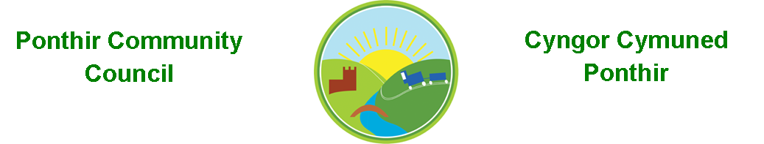
1st November 2023

Dear Councillor,
You are summoned to attend the Monthly Meeting to be held on Monday 13th November 2023 @ 7pm at PSCC School Close.

PLEASE NOTE CHANGE OF VENUE

Should anyone wish to access the meeting remotely, please contact the Clerk, at least three working days prior to the meeting.

Press and public welcome.
Mrs. Clare Danaher Clerk PCC

Agenda
- Present
- Guests
- Apologies for absence (To be agreed by Councilor’s present)
- Declarations of Interest
- To consider matters raised by the members of the public

- To approve the minutes of the meeting held on 9th October 2023
- Matters arising
  - Bio-Diversity Plan
  - Training
  - Christmas Fayre
  - Christmas trees and lights
  - RLDP (Cllr Matthews)
  - Defib course
  - Table Tennis Club
  - Quarterly bank reconciliation

- To consider and discuss items
- Code of Conduct
- Newsletter
- Pathways (Cllr Buffery)
- Conflict of Interest Page 1 of 2

9.Finance and Accounts

Balance of Direct Plus Account as of 31st October 2023 £11,283.16

To Note Invoices Paid and Credits Received – to 31st October 2023

2 OCT 23 POPPY PINS 12.00CR
3 OCT 23 Paul Davies Printing 45.00
3 OCT 23 Enerveo Limited 1,008.00
4 OCT 23 Microsoft 11.28
6 OCT 23 ADOBE 19.97
9 OCT 23 Amazon Shredder 40.99
9 OCT 23 PSCC Firework Banners 200.00
26 OCT 23 Clerk Phone 19.00
26 OCT 23 Torfaen CBC 805.00
30 OCT 23 Morris’s of Usk 12.00
30 OCT 23 XL Graphics 168.00

10. Planning

New building to accommodate Community hub/club, construction of car park and delivery area at Sports Pavilion School Close Ponthir.

Planning application received 27th October 2023.

11. To Note Correspondence Received

TCBC x 44
Others x 53
One Voice Wales x 18
Health Board x 11

12. Committee Reports

Ponthir Church in Wales Primary School.
Torfaen County Association of Local Councils.
Gwent Valleys Partnership.
Ponthir Village Hall.
PSCC.
Mick Morris Memorial Sporting Trust

This document is available on our website www.ponthircommunitycouncil.gov.uk
A copy of this document could be made available in Welsh. Please contact us on the telephone number or e-mail below.
Mae dogfen yma yn ar gael mewn gwefan ni www.ponthircommunitycouncil.gov.uk Mae copi or ddogfen hon ar gael yn Gymraeg.
Cysylltwch a ni ar y rhif ffôn neu drwy e-bost isod.
Telephone/ Ffôn: 07454 988250 E-Mail/ E-bost: clerk@ponthircommunitycouncil.gov.uk
Page 2 of 2

