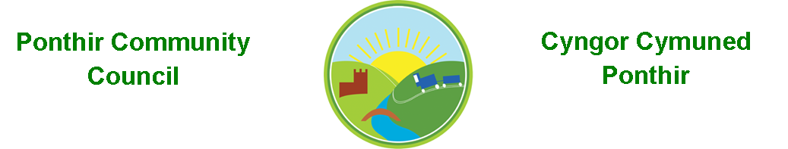
1st December 2023

Dear Councillor,
You are summoned to attend the Monthly Meeting to be held on Monday 11th December 2023 @ 7pm at PSCC School Close Ponthir.

Should anyone wish to access the meeting remotely, please contact the Clerk, at least three working days prior to the meeting.

Press and public welcome.
Mrs. Clare Danaher Clerk PCC

Agenda
- Present
- Guest. Steve Williams TCBC.
- Apologies for absence (To be agreed by Councilor’s present)
- Declarations of Interest
- To consider matters raised by the members of the public.

- To approve the minutes of the meeting held on 13th November 2023

- Matters arising
  - Training
  - Christmas Fayre
  - Christmas trees and lights
  - RLDP (Cllr Matthews)
  - Defib course
  - Email protocol.
  - PCSO update

- To consider and discuss items.
- Dates and venue for 2024
- Budget/Newsletter meeting in January
- Community Review
- Audit Wales 22/23
- Dedication Ceremony update

Page 1 of 2

9.Finance and Accounts

Balance of Direct Plus Account as of 30th November 2023 £9,315.11

6 NOV Microsoft 11.28
6 NOV Adobe 19.97
9 NOV HCI Data Ltd 130.80
15 NOV OVW Training 152.00
16 NOV British Legion 330.00
27 NOV Clerk Phone 19.00
27 NOV Christmas Fayre 600.00
27 NOV TCBC 805.00

29 NOV Christmas Fayre 100.00 CR

To Note Invoices Paid and Credits Received – to 30th November 2023

10. Planning

None

11. To Note Correspondence Received

TCBC x 51
Others x 40
One Voice Wales x 15
Health Board x 9

12. Committee Reports

Ponthir Church in Wales Primary School.
Torfaen County Association of Local Councils.
Gwent Valleys Partnership.
Ponthir Village Hall.
PSCC.
Mick Morris Memorial Sporting Trust

This document is available on our website www.ponthircommunitycouncil.gov.uk
A copy of this document could be made available in Welsh. Please contact us on the telephone number or e-mail below.
Mae dogfen yma yn ar gael mewn gwefan ni www.ponthircommunitycouncil.gov.uk Mae copi or ddogfen hon ar gael yn Gymraeg.
Cysylltwch a ni ar y rhif ffôn neu drwy e-bost isod.
Telephone/ Ffôn: 07454 988250 E-Mail/ E-bost: clerk@ponthircommunitycouncil.gov.uk
Page 2 of 2

