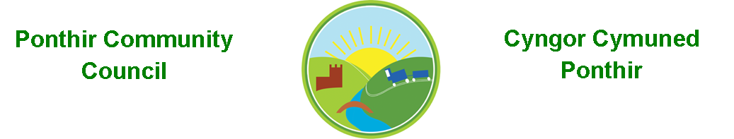
8th April 2024

Dear Councillor,
You are summoned to attend the monthly meeting to be held on Monday 15th April 2024 @ 7pm at Ponthir Village Hall.

Should anyone wish to access the meeting remotely, please contact the Clerk, at least three working days prior to the meeting.

Press and public welcome.
Mrs. Clare Danaher Clerk PCC

Agenda
- Present
- Apologies for absence (To be agreed by Councilor’s present)
- Declarations of Interest
- To consider matters raised by the members of the public.

- Jan Whitham Community Engagement Officer TCBC

- To approve the minutes of the meeting held on 11th March 2024

- Matters arising
  - Email protocol
  - Defib Llanfrechfa
  - Candwr Lane trees
  - Waste management costs - PVH
  - Planters

- To consider and discuss items.
- Declarations of Interest
- Newsletter
- Christmas tree lights
- OVW Award Ceremony
- Using Websites, IT, and social media
- New Councillor photos
- Training
- S Bailey Memorial
- Email Minutes and Agenda

- Finance and Accounts
Balance of Direct Plus Account as of 26th March 2024 £ 7,680.73

Page 1 of 2

1st March Clerk Phone 19.00
4th March Print Shop 12.00
6th March Microsoft 12.36
6th March Adobe 19.97
11th March Gift 7.99
11th March HCI Data 16.80
15th March OVW 60.00
26th March TCBC 880.00

11th March Credit received Village Hall marquee repair 40.00

To note invoices paid and credits received – to 26th March 2024

10. Planning

None

11. To note correspondence received

TCBC x 37
Others x 44
One Voice Wales x 20
Health Board x 9

12. Committee Reports

Ponthir Church in Wales Primary School.
Torfaen County Association of Local Councils.
Gwent Valleys Partnership.
Ponthir Village Hall.
PSCC.
Mick Morris Memorial Sporting Trust

This document is available on our website www.ponthircommunitycouncil.gov.uk
A copy of this document could be made available in Welsh. Please contact us on the telephone number or e-mail below.
Mae dogfen yma yn ar gael mewn gwefan ni www.ponthircommunitycouncil.gov.uk Mae copi or ddogfen hon ar gael yn Gymraeg.
Cysylltwch a ni ar y rhif ffôn neu drwy e-bost isod.
Telephone/ Ffôn: 07454 988250 E-Mail/ E-bost: clerk@ponthircommunitycouncil.gov.uk

Page 2 of 2

